Swavy Spare – How to Use
Buy and sell preloved phones, laptops and gadgets in Lagos and Abuja – safely.

What it does
- Sell in 3 steps: pick the model → answer Yes/No condition questions → add photos, IMEI and price. Get an instant suggested price range.
- Swavy Checker: a verified tech checker checks the IMEI against the stolen list, tests the device and grades it A, B or C. Checked listings get a Swavy Checked badge.
- Buy safely: Money held (simulated) → meet or delivery → buyer gives the seller a 4-digit code → Money released.
- Offers, a Safety page to check an IMEI or report a stolen device, dashboards for sellers, checkers and admin.
- Filters, light/dark mode, installable as an app, WhatsApp share buttons.

How to open it on Windows
1. Open the swavy-spare folder.
2. Double-click start.bat.
3. Your browser opens http://localhost:3001 (next free port if busy). It can run at the same time as Swavy Fix (3000).
4. Keep the black window open.

Demo logins (password for all: swavy123)
Who | Email | What to try
Buyer (Lekki) | buyer@swavy.ng | An offer waiting on an iPhone 12
Seller (Ikeja) | seller@swavy.ng | Listings, an offer, a past sale, a check booked
Tech Checker (Lagos) | checker@swavy.ng | A booked check to do
Tech Checker (Abuja) | checker2@swavy.ng

Admin page: http://localhost:3001/#/admin – password swavyadmin.
Stolen test IMEI: 356938035643809 (gets blocked). Clean test IMEI: 490154203237518.

Step by step

Sell a gadget
1. Log in as seller@swavy.ng and choose Sell.
2. Pick the device type and model.
3. Answer the Yes/No questions – the price estimate updates as you go.
4. Add photos, the IMEI and your price, then list it. Book a Swavy Checker.
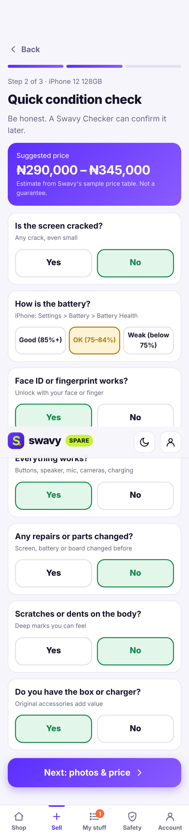
Condition questions and instant estimate
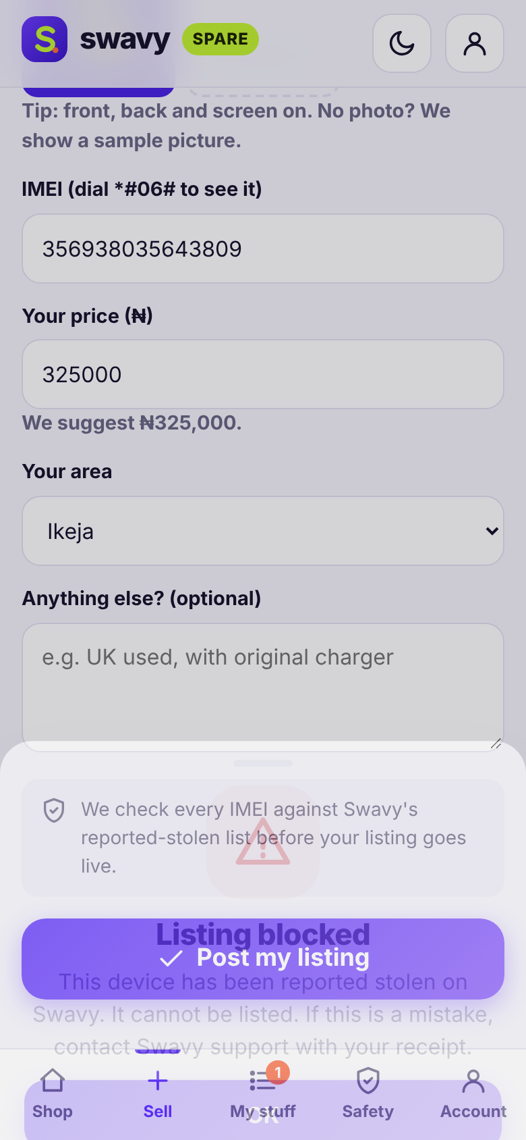
A reported-stolen IMEI is blocked

Checker: grade a device
1. Log in as checker@swavy.ng and open the booked check.
2. Mark Pass/Fail for each item and enter battery health.
3. The app works out the grade: A (all pass, battery 85%+), B (one minor fail or 75–84%), C (anything else), Failed (account lock on or stolen).

Buy safely
1. Log in as buyer@swavy.ng, open a listing and order (or make an offer).
2. The money shows as Money held.
3. Meet in a safe public place or get delivery, test the device, then give the seller your 4-digit code – the money is released. You can cancel for a refund before release.
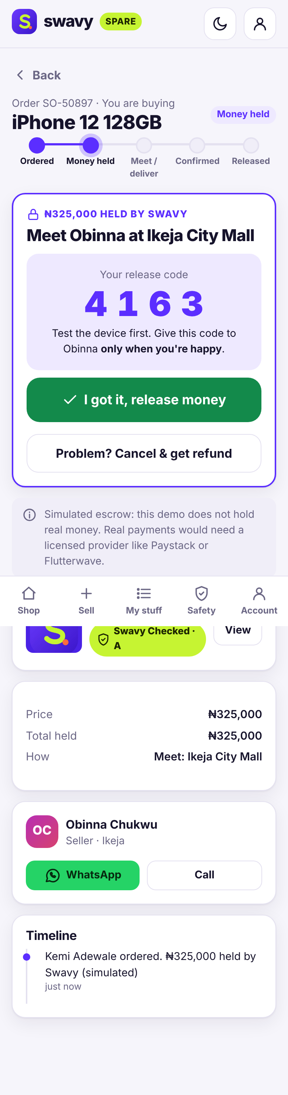
Money held until you confirm

Your data and the database
Everything is saved in one file: data\swavy-spare.db inside the Swavy Spare folder. It is created the first time you start the app.

Look inside
- Open a Command Prompt in the folder (click the address bar in File Explorer, type cmd, press Enter) and type npm run db to list every table and how many rows it has.
- Type npm run db -- listings to see the latest rows of one table.
- Or install the free DB Browser for SQLite (https://sqlitebrowser.org) and open the .db file. Stop the app first.

Start fresh (reset)
1. Close the black window to stop the app.
2. Delete the data folder inside the project folder.
3. Double-click start.bat again. The sample data is created again.

Troubleshooting
Problem | What to do
The black window says "Node.js ... was not found" | Install Node.js 24 LTS from https://nodejs.org, restart the computer, then double-click start.bat again.
Port 3001 is busy / another app is open | Close the other black window (or the other app) and try again. The app tries the next free port automatically – read the address printed in the black window and type it into your browser.
The browser did not open | Open Chrome or Edge yourself and go to http://localhost:3001 (or the address shown in the black window).
The page will not load | Make sure the black window is still open. Closing it stops the app.
Windows SmartScreen / firewall warning | Click "More info → Run anyway" for start.bat. If asked about the firewall, choose Private networks.

Honest limitations
- Payments are simulated. "Money held" and "Money released" are labels only. Real escrow needs a licensed provider like Paystack or Flutterwave.
- The reported-stolen IMEI list is a local demo list – not connected to any police or network database.
- Price estimates use sample base prices and are labelled as estimates. All people and devices are samples.

